**YOU can do COMMERCIAL SPACE**

**U**

**N**

**H**

**S**

**E**

**D**

**S**

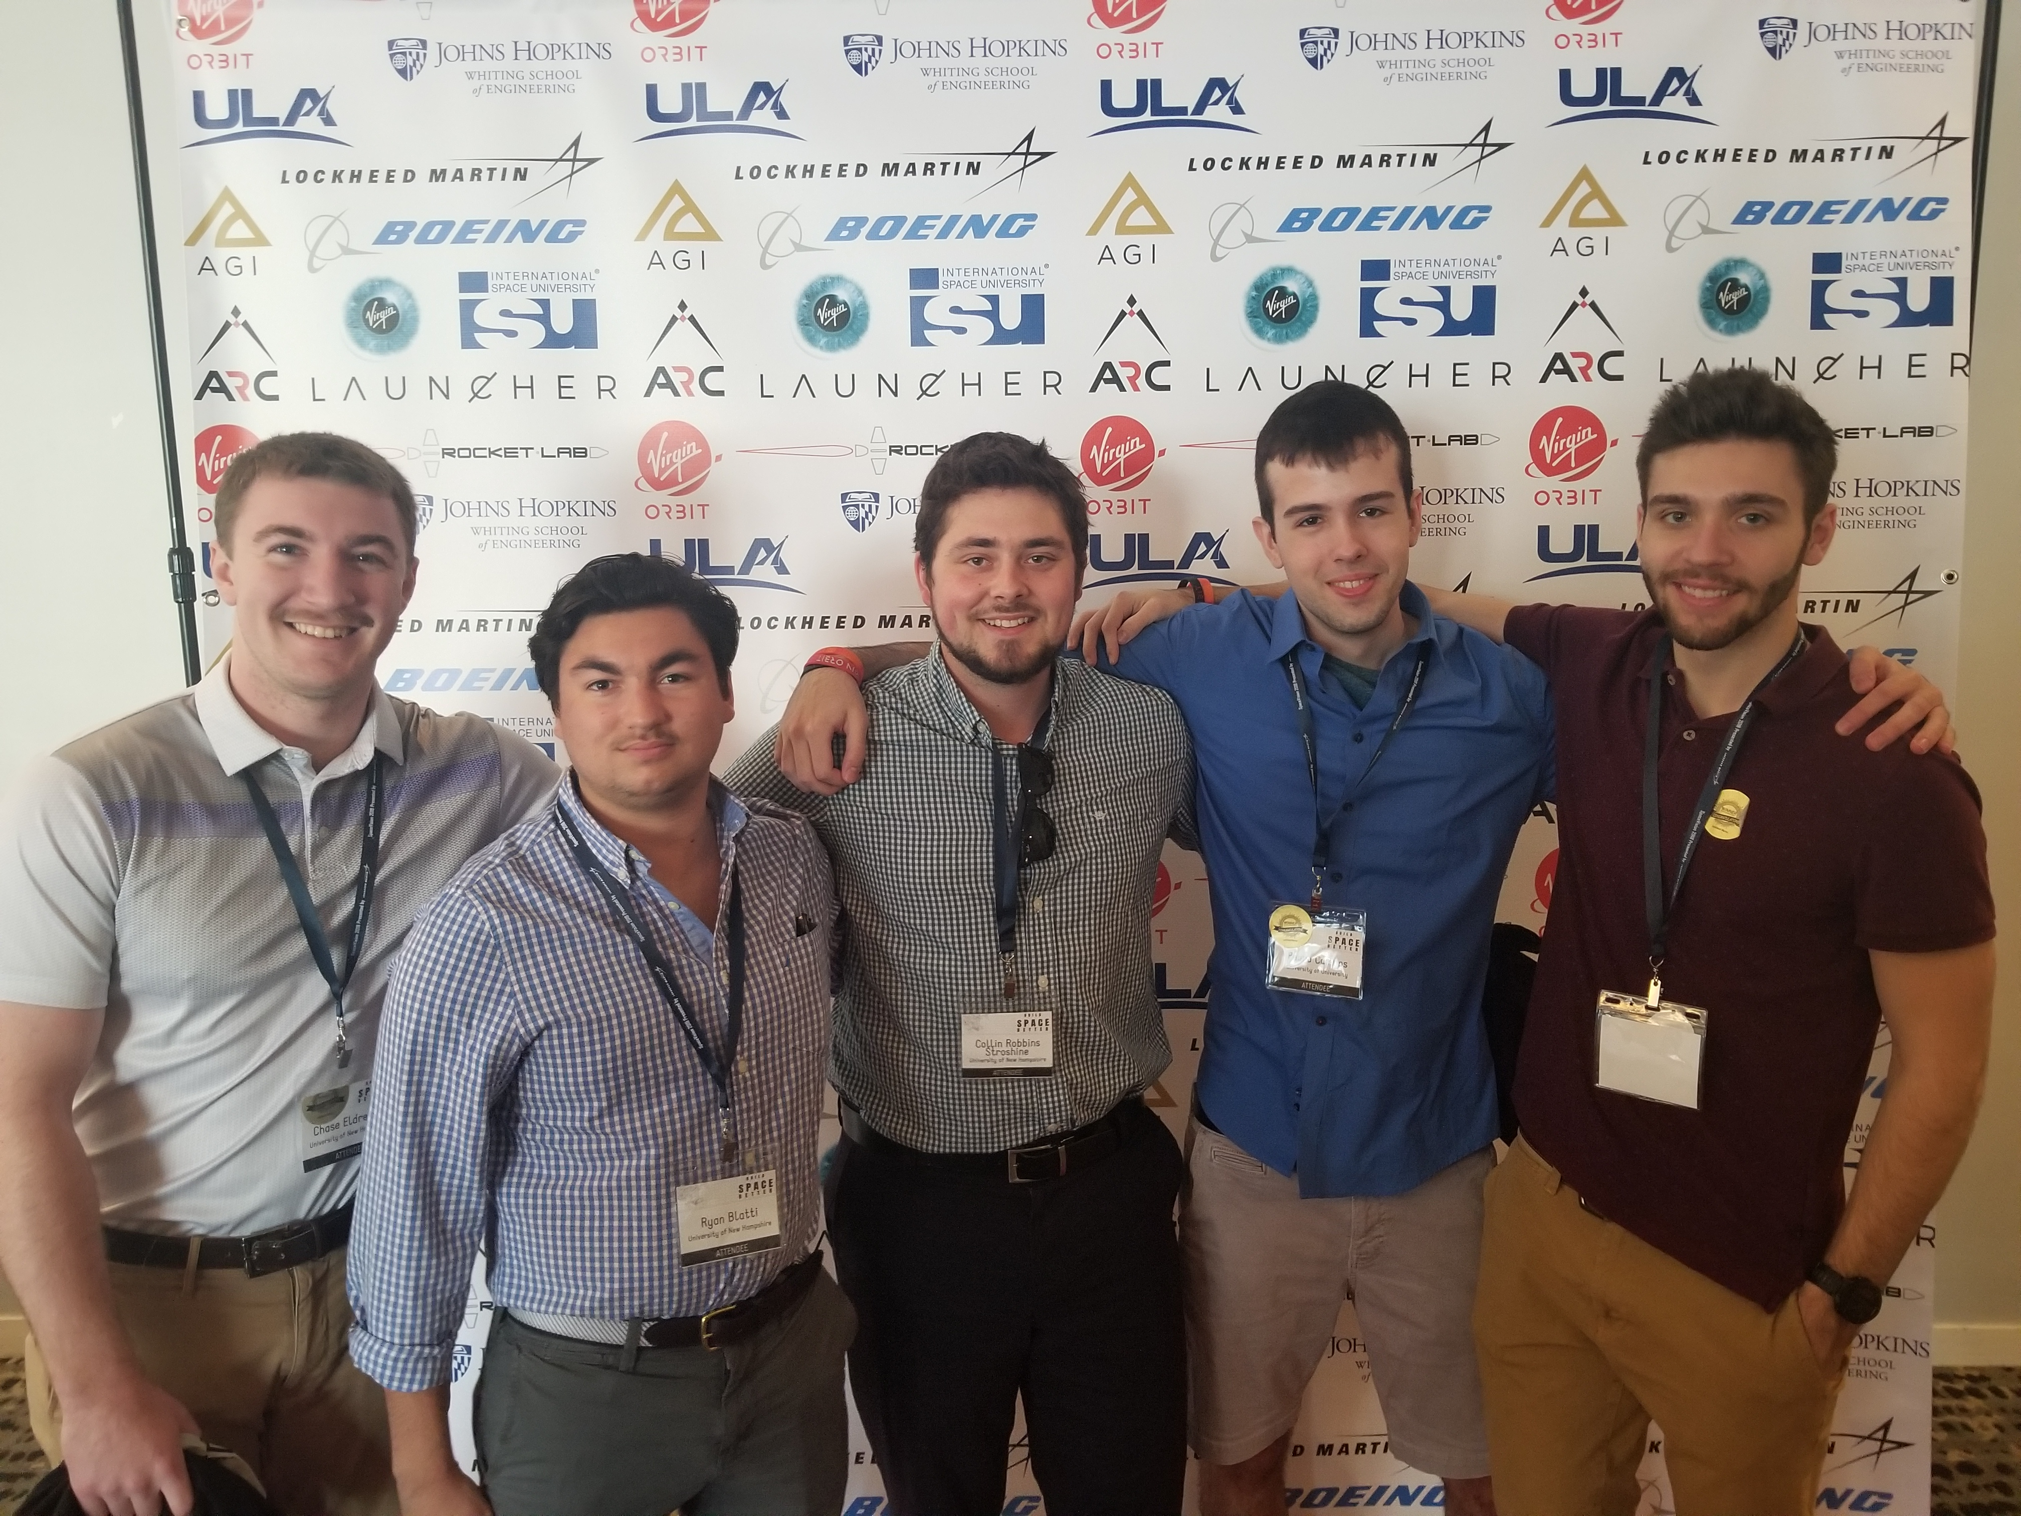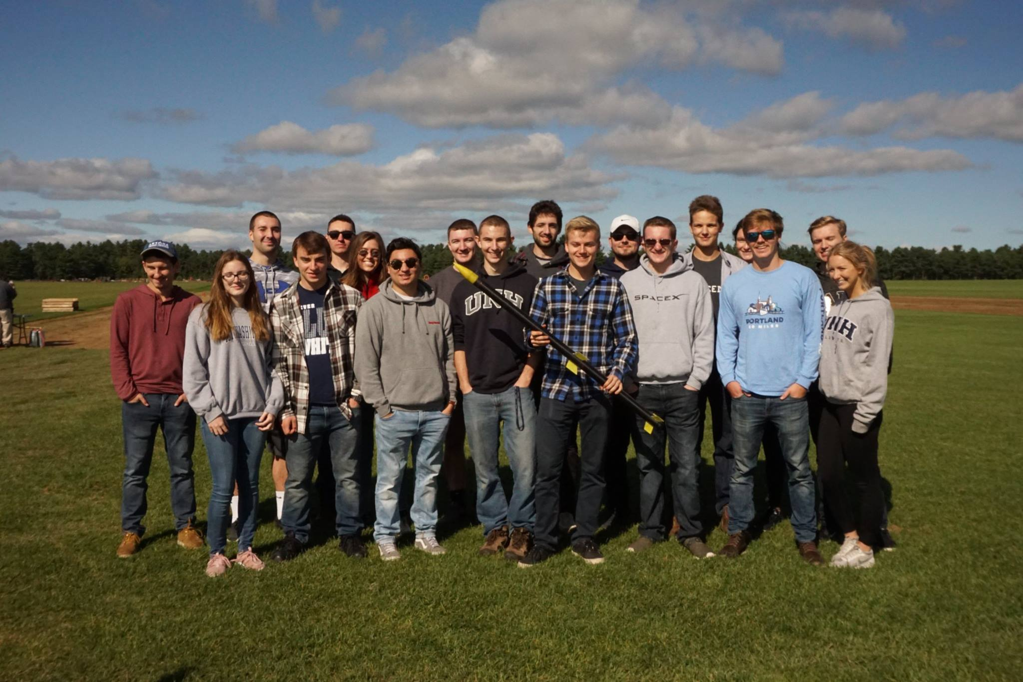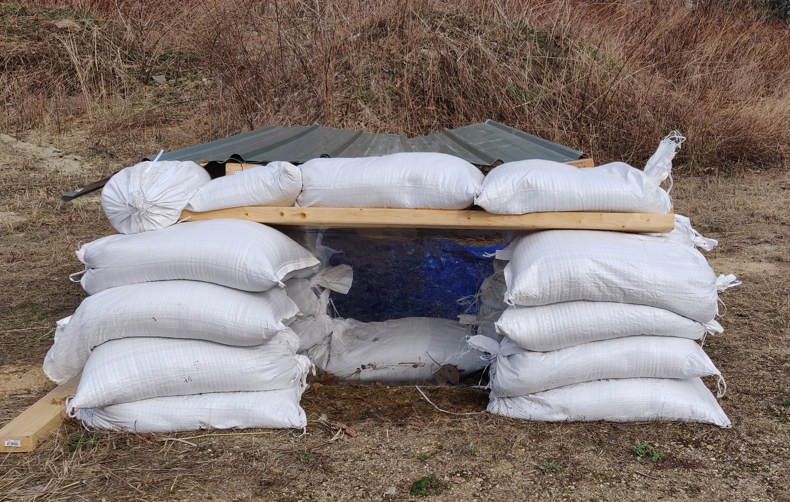

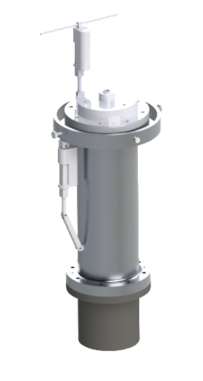

**CONTROL BUNKER**

**GIMBAL RENDER**

**MULTI-STAGE LAUNCH**

**2018-2019 SENIORS**